

TMX PowerStream RTD (Real-Time Data)

How to Use RTD?
Data Point Coverage
Data Point Format
System Requirements
Troubleshooting
Frequently-Asked Questions (FAQ)

TMX PowerStream’s RTD functionality allows you to stream dynamic, real-time quote data to MS Excel spreadsheets in the Windows operating system.

This powerful tool greatly extends your control, whether you simply prefer to view live market data in a spreadsheet, or wish to perform specialized calculations and use specific Excel features such as charting, data aggregation, conditional formatting, macros, etc. As data updates in TMX PowerStream, the same data updates accordingly in your spreadsheet, embedded in streaming real time.

With TMX PowerStream RTD, you can track a wide range of stock market statistics, from basic stock quote data (last price, volume, change, bid, ask) to price statistics (52-week high, 52-week low) and valuation parameters (earnings per share, PE ratios, dividend yields). Data for up to 500 symbols is supported.

Having troubles connecting to the service?
Please see further on in this document for trouble shooting tips.

How to use RTD?

Using TMX PowerStream RTD is easy. After logging on to TMX PowerStream, open a new Excel workbook and enter an RTD function as follows:

=RTD("TMX PowerStream.rtdserver",,"MSFT:US","Last")
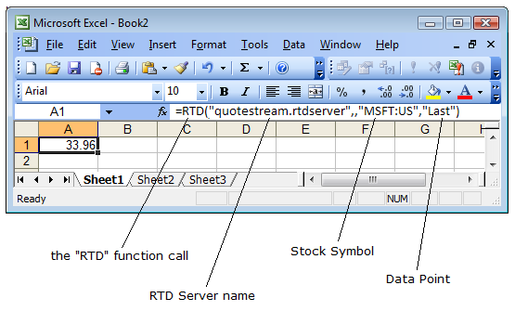

There are 4 parts to an RTD function:

- RTD Function Call – this is how Excel knows that you are calling an RTD function.

- RTD Server Name – the name of the RTD server where the function gets processed. In this case, the value is always "TMX PowerStream.rtdserver".

- Stock Symbol – a symbol of a stock or other financial instrument.

Note: Symbols containing an @ (ie - options symbols) must be escaped with a single quote.
For example, @APVIN needs to be entered into Excel as '@APVIN

- Data Point – the data point you wish to request (see “Data Points” further on in this document).

Note the two commas that come after the RTD server name and the single comma that comes after the stock symbol.

You can build your RTD spreadsheets from scratch by manually inputting RTD functions to an Excel spreadsheet. Alternatively, you can simply use one of several pre-defined RTD Excel spreadsheets we can provide for you, and customize it to your needs.

You can download Sample RTD Excel Spreadsheets from this web page:

https://tmxpowerstream.com/RTDdocs.php

Data Point Coverage

Data Points are available in long or short form for your convenience. Either may be used.

For example: =RTD("TMX PowerStream.rtdserver",,"MSFT:US","Last Trade Time") will return the same result as
=RTD("TMX PowerStream.rtdserver",,"MSFT:US","Ltime")

Long Name | Short Name |  | Long Name | Short Name
Last Price | Last |  | Performance 1 Month | P1M
Change | Chg |  | Performance 1 Month Percent | P1M%
Percent Change | PChg |  | Performance 3 Month | P3M
Tick | Tick |  | Performance 3 Month Percent | P3M%
Last Trade Time | Ltime |  | Performance 6 Month | P6M
Last Trade Size | LSize |  | Performance 6 Month Percent | P6M%
Bid Price | Bid |  | Performance 1 Year | P1Y
Bid Size | Bsize |  | Performance 1 Year Percent | P1Y%
Ask Price | Ask |  | Performance 3 Year Cumulative | P3YC
Ask Size | Asize |  | Performance 3 Year Annualized | P3YA
Open Price | Open |  | Performance 5 Year Cumulative | P5YC
High | Hi |  | Performance 5 Year Annualized | P5YA
Low | Lo |  | Performance 10 Year Cumulative | P10YC
52 Week High | 52wHi |  | Performance 10 Year Annualized | P10YA
52 Week High Date | 52wHiD |  | Average Volume 10 Day | AV10D
52 Week Low | 52wLo |  | Average Volume 20 Day | AV20D
52 Week Low Date | 52wLoD |  | Average Volume 30 Day | AV30D
Value | Val |  | Average Volume 50 Day | AV50D
Close Price | Close |  | Average Volume 90 Day | AV90D
Previous Close | Pclose |  | Average Volume 100 Day | AV100D
Volume | Vol |  | Average Volume 365 Day | AV365D
VWAP | VWAP |  | Pre Market Last | PreLast
TWAP | TWAP |  | Pre Market Change | PreChg
Tick Volume | Tvol |  | Pre Market Percent Change | PrePChg
Open Interest | OpenInt |  | Pre Market Volume | PreVol
YTD | YTD |  | Pre Market Trade Time | PreLtime
YTD% | YTD% |  | Post | Post
21 Day Moving Average | MA21 |  | Post Market Last | Post Last
50 Day Moving Average | MA50 |  | Post Market Change | PostChg
200 Day Moving Average | MA200 |  | Post Market Percent Change | PostPChg
 |  |  | Post Market Volume | PostVol
 |  |  | Post Market Trade Time | PostLTime

Long Name | Short Name |  | Long Name | Short Name
Standard Deviation | Stddev |  | Return on Assets | ROA
Alpha | Alpha |  | Return on Assets LTM | ROALTM
Beta | Beta |  | Return on Capital | ROC
Gamma | Gamma |  | Return on Capital LTM | ROCLTM
Rho | Rho |  | Return on Equity | ROE
Theta | Theta |  | Return on Equity LTM | ROELTM
Vega | Vega |  | Return on Invested Capital 1YR | ROIC1YR
Delta | Delta |  | Return on Invested Capital QTR | ROICQTR
R-Squared | R2 |  | P/B Ratio | PBRAT
Intrinsic Value | Intrinsic |  | PE Ratio | PER
Extrinsic Value | Extrinsic |  | Enterprise Value | EV
Bid Implied Volatility | BidIV |  | Symbol | Symbol
Ask Implied Volatility | AskIV |  | Description | Desc
Implied Volatility | IV |  | Firm Name | Firm Name
Implied Volatility Change | IVChg |  | Currency | Curr
Mark | Mark |  | Marketplace | Market
Mark Change | MarkChg |  | Exchange | Exch
Mark Change Percent | MarkChg% |  | Industry | IND
Previous Mark | PMark |  | SubIndustry | IND2
Market Cap | MCap |  | Sector | SCT
Dividend | Div |  | Shares Outstanding | SHOS
Ex-Div | ExD |  | TRIV | TRIV
Dividend Current Payout Ratio | DivPayout |  | Short Sale Restriction | regSHO
Yield | Yld |  | Short Interest Avg Daily Volume | AvgDaily
Earnings Per Share | EPS |  | Short Interest Settlement Date | SettleDay
Earnings Quarter End | EarnQuartEnd |  | Performance 1 Month | P1M
Next Earnings Date | NextEarnDate |  | Performance 1 Month Percent | P1M%
ShortInterestRatio | ShortRatio |  | Performance 3 Month | P3M
ShortPosition | Short |  | Performance 3 Month Percent | P3M%
ShortPositionChange | ShortChg |  | Performance 6 Month | P6M
ShortPositionPercentChange | ShortPChg |  | Performance 6 Month Percent | P6M%
Panel | Panel |  | Performance 1 Year | P1Y
 |  |  | Performance 1 Year Percent | P1Y%

System Requirements

RTD requires a Windows machine with MS Excel 2002 or higher.

QuoteMedia’s TMX PowerStream RTD feature takes advantage of the RTD (formerly DDE, “Dynamic Data Exchange”), and OLE (“Object Linking and Embedding”) document standards developed by Microsoft Corporation, for MS Excel. These standards allow the creation of objects in one application to be linked or embedded in a second application. Embedded objects retain their original format and links to the application that created them.

These Microsoft standards are available only in Excel 2002 and higher. Consequently, TMX PowerStream RTD is supported only in these Excel versions.

Trouble Shooting

If you are having trouble connecting to the service, please start by trying the following steps:

Step 1
The Operating System, the version of TMX PowerStream and the version of Microsoft Excel MUST all be either 32-bit or 64-bit. You cannot mismatch a 64-bit TMX PowerStream with a 32-bit Microsoft Excel and vice versa. If using the Webstart Installer then Java must match Excel, so 32-bit Java for 32-bit Microsoft Excel. Supported version of RTD vs Office include:
32-bit OS + 32-bit Java + 32-bit Office
64-bit OS + 32-bit Java + 32-bit Office
64-bit OS + 64-bit Java + 64-bit Office

To ensure that 32-bit Java is set on your computer click here

Step 2
Ensure that all Excel sheets and the Excel program are closed first; only open Excel after TMX PowerStream has been opened.

Step 3
Allow permissions to Excel and Java through your firewall, possibly both public and private depending on where you are accessing the application from. Both a Windows and a third party firewall service should be adjusted to allow Excel and Java access.

Set trusted application settings in Excel if not automatically done. File > Options > Trust Center > Trust Center Settings…> Under Trusted Documents, ensure “Allow documents on a network to be trusted?” is selected.

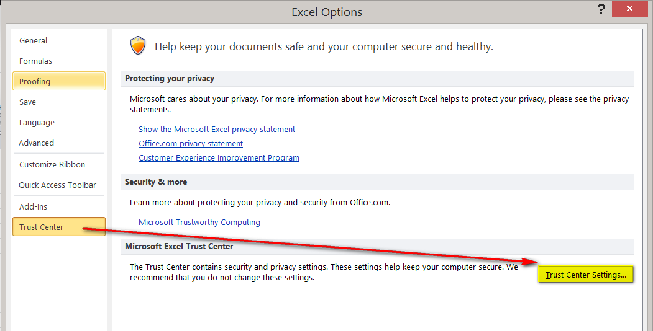

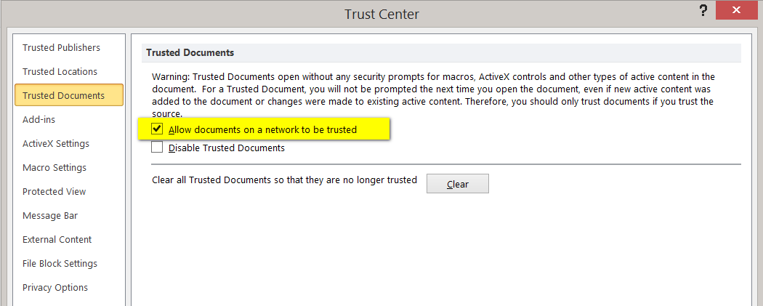

For Win7 users: Under Trust Center Settings > Locations, select "Add new location" then select "The Sub -Folders of this location are Trusted" > click Browse and locate the following folder to add: C:\ProgramData\QuoteMedia\resources\nativelibs

For Win8 and Win10 users: Under Trust Center Settings > External Content, select > Enable all Data Connections – and > Enable automatic update for all Workbook links

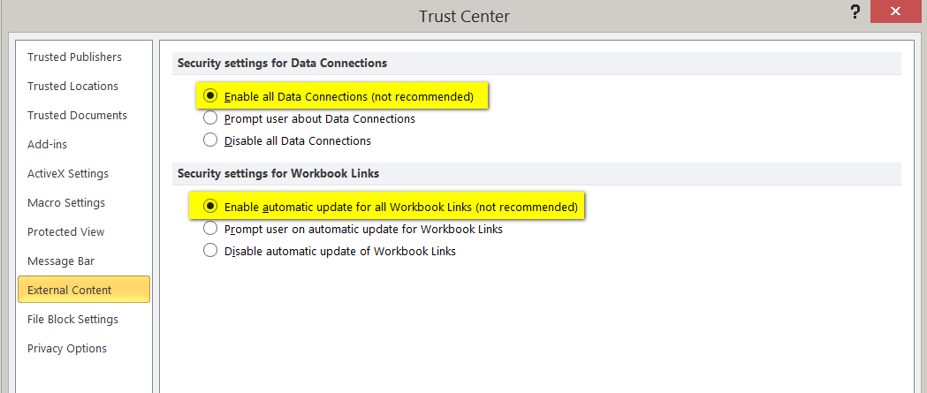

Under Trust Center Settings > ActiveX Settings > Select “Enable all Data” and “Enable automativ update for all Workbook links”

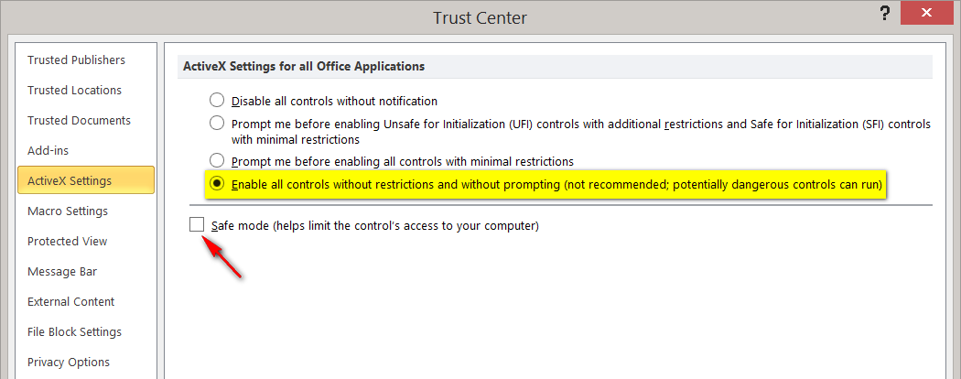

Under Trust Center Settings > Macro Settings > Select “Enable all Macros”

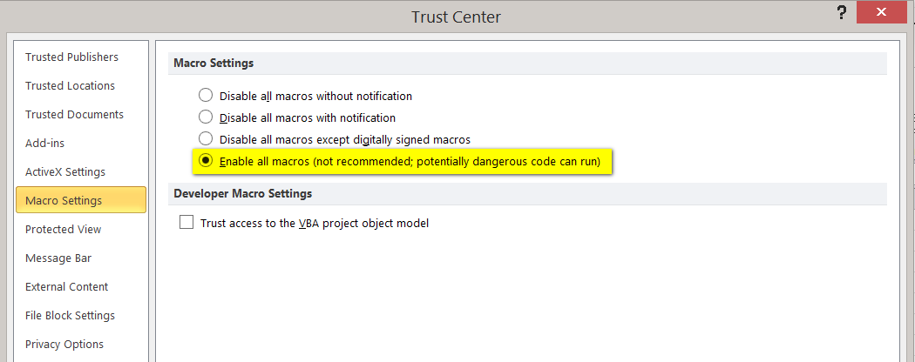
Step 4
Update Java and clear Java cache: https://www.java.com/en/download/help/plugin_cache.xml

Step 5
Update Windows User Control Settings; lowering controls to “Never Notify” has solved problems in the past. http://windows.microsoft.com/en-ca/windows7/how-do-i-change-the-behavior-of-user-account-control-by-using-the-slider

Step 6 (Not Applicable for Desktop version of TMX PowerStream)
Ensure that Java is running in the appropriate bit version to your version of TMX PowerStream and Microsoft Excel. It is possible to have the 32-bit and 64-bit versions of Java on your computer at the same time and your computer may choose to use the version 64-bit of Java even though you are running the 32-bit version of TMX PowerStream and Microsoft Excel. First confirm which versions of Java that you have by going into ‘Configure Java’ which you can type into your Windows search area, or finding in the ‘Java’ folder in your Start Menu.

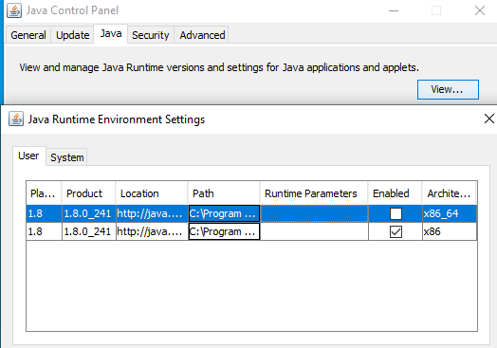

First, click on the ‘Java’ tab up at the top and then on the ‘View’ button to the right as shown in the picture above. You can tell the bit version of Java that you have by looking in the very far right column under Architecture, the ‘x86_64’ is the 64-bit version while the ‘x86’ version is the 32-bit version.

If you are missing the bit version of Java then you can download it from this website: https://www.java.com/en/download/manual.jsp

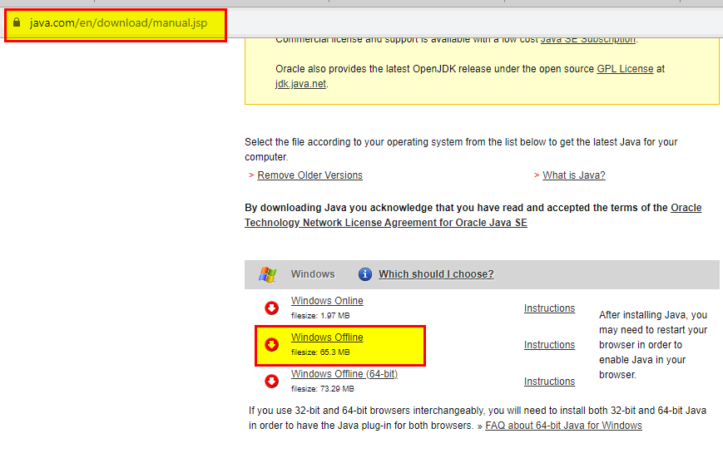
Highlighted in the picture above is the 32-bit Java version, so select that one if it is the one you are missing or select the one below, which is for the 64-bit Java version. Then after you download and install it, you can bring up the Configure Java program again and this time select the correct bit version of Java you want to have running.

Frequently-Asked Questions (FAQ)
- What do I need to install to use RTD?

You do not need to install any additional software. All you have to do is log on to TMX PowerStream. TMX PowerStream does all the setup and configuration for you in the background.

- The quotes appearing on the Excel spreadsheets seem to update only every two seconds – how can I get the spreadsheet to update faster?

Excel RTD is set to update every 2 seconds by default. This is called the Throttle Interval. You can change the default Throttle Interval in Excel by going to Tools → Macro → Visual Basic Editor. From the Visual Basic Editor, go to View → Immediate Window. On the Immediate Window, type in

Application.RTD.ThrottleInterval=0

and press Enter. Setting the Throttle Interval to 0 means that the spreadsheet is refreshed as soon as there are updates.

Click here for more information on the Throttle Interval.

- I am getting #N/A when I open my RTD spreadsheet, what should I do?

Check that you are properly logged on and getting streaming data on TMX PowerStream.

